**Labelling the Images**

We used an application called objectmarker.exe to label our images.

We have a folder containing the following files/folder:

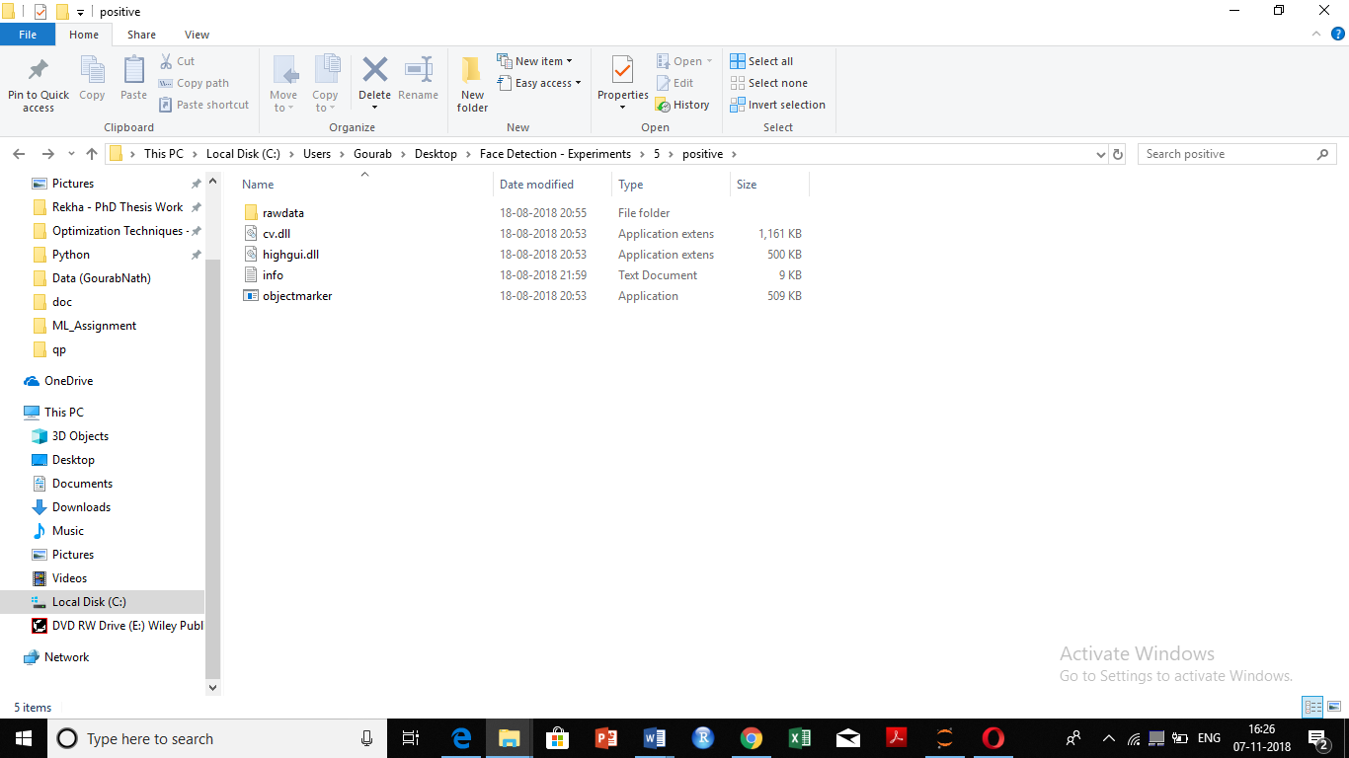

The raw data contains all the positive images to be labelled. Cv.dll and highgui.dll are two libraries. In order to label the images, we take the following steps:

1. Open the application objectmarker.exe

CMD prompt opens along with another window with an image file from the rawdata folder.

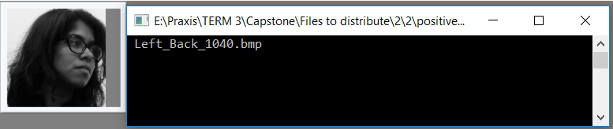

1. Select and drag mouse to choose the coordinate. (Drag it from top left or bottom right)

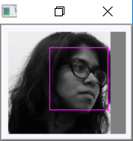

**Important note:** Take care to always start the bounding box at either the top left or bottom right corner. If you use the other two corners objectmaker.exe will not write the coordinates of the selected object into the info.txt file.

1. Press SPACE to record the co-ordinate.

After this, the rectangle position and its size will appear on the left window (see below).

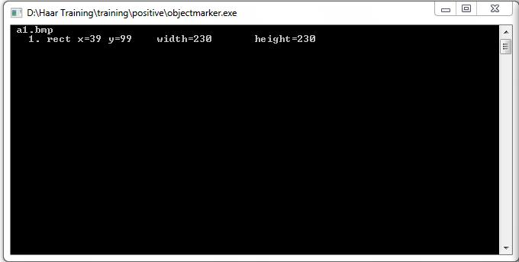

CAUTION: DO NOT hit space twice for the same rectangle. Then there will be duplicate record

1. For image with multiple faces, repeat steps 2 and 3.
2. Press ENTER to go to the next image.

**Remark 1**: This process of labelling is a loop. It continues until all the images are labelled inside the rawdata folder. After all the images are labelled the window automatically closes.

The records are stored in the info.txt file. We will use this file to train the model (i.e. create XML files).

**Remark 2:** Every time objectmarker.exe is run, it will overwrite the previous info.txt file without any notice and creates empty new info.txt; i.e you will lose your previous works.

Here is an example of how the records gets stores in the info.txt file.

|  |  |  |  |  |  |  |  |  |  |  |  |
| --- | --- | --- | --- | --- | --- | --- | --- | --- | --- | --- | --- |
| rawdata\image1200.bmp **1** | | 34 | 12 74 | 24 | 40 | 95 80 | 92 | 120 | 40 | 45 | 36 |
| rawdata\image1201.bmp | **3** | 35 | 25 70 | 39 |
| rawdata\image1202.bmp | **2** | 10 | 24 90 | 90 | 45 | 68 99 | 82 |  |  |  |  |

The first number in each line defines the number of existing objects in the given image. For example, in second line, the number **3** means that you already selected three objects (e.g. face) within image1201.bmp. The next four numbers (shown in green) defines the location of first object in the image (top left vertex: x=35, y=24, width=70 and height=39). The red numbers identify the data for the second object; blues ones are for the third object, and so forth.

Note: Errors like this line: **rawdata/d19.bmp** **3** **83 119 185 183** can lead to serious hidden issues while training your cascade. Before going further, make sure every line in info.txt is correct. Error in above example is the number **3** while it should be **1.**